**Stack And Queue Data Structure**

**LIFO Principle of Stack**

In programming terms, putting an item on top of the stack is called push and removing an item is called pop.

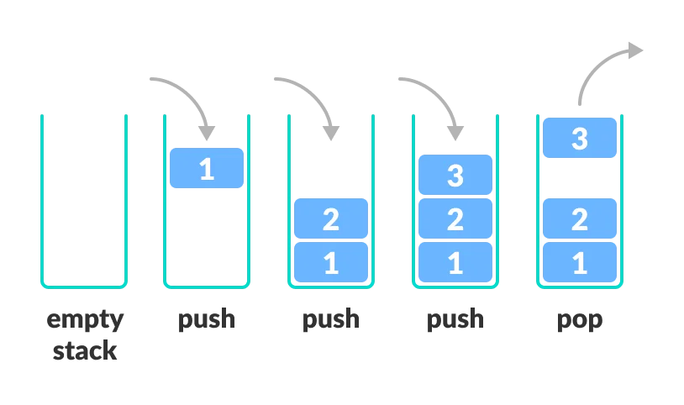

**Basic Operations of Stack**

**Push:** Add an element to the top of a stack

**Pop:** Remove an element from the top of a stack

**IsEmpty:** Check if the stack is empty

**IsFull:** Check if the stack is full

**Peek:** Get the value of the top element without removing it

**First In First Out (FIFO) Principle of Queue**

the item that goes in first is the item that comes out first.

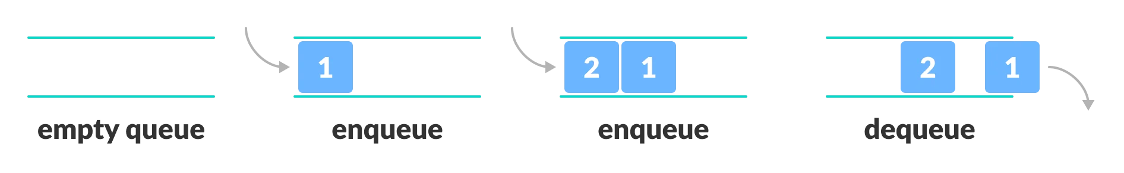

**Basic Operations of Queue**

**Enqueue:** Add an element to the end of the queue

**Dequeue:** Remove an element from the front of the queue

**IsEmpty:** Check if the queue is empty

**Peek:** Get the value of the front of the queue without removing it

Problems :

1. **Stack vs Queue principle**
2. **Reverse a stack**
3. **Reverse a string using stack**
4. **Reverse a queue**
5. <https://leetcode.com/problems/valid-parentheses/description/>
6. <https://leetcode.com/problems/min-stack/description/>
7. <https://www.geeksforgeeks.org/problems/reverse-first-k-elements-of-queue/1>

git HUB: <https://github.com/abdullahallnaim/phitron-batch4-codes/tree/main/DS/Week_4?fbclid=IwAR02tqK4_Sj2YUXDFqMp-Z_VgHNCkAx8Hw7pWGPZtQnm57oZVSCWz7mlQBw>